LIST OF ADVANCE LEARNERS (2021-22)
CLASS: M.A(ECONOMICS) SEM II
Name of the student | College roll no. | Marks obtained in house test(out of 20) | Members of any society/  Organization etc. | Measures taken /  Opportunities given to further enhance skills and confidence of the students | Achievements /outcomes (Marks obtained in university exams out of 1000) | Proof of the achievements
Neha Rani | 16501 | 19/20 | Member of discipline committee |  | 855/1000 | 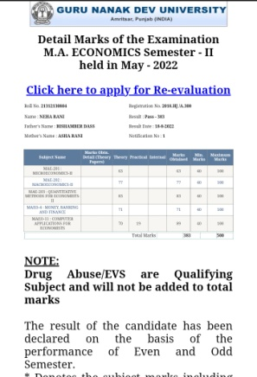
Priya | 16503 | 19/20 |  | Webinars, PPT Competition and Online quiz competition | 828/1000 | 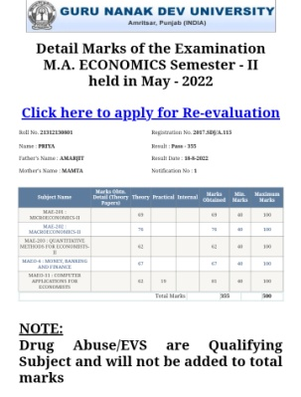
Tanisha | 16509 | 18/20 |  |  | 776/1000 | 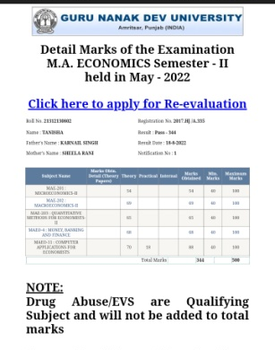

CLASS: M.A(ECONOMICS) SEM IV

Name of the student | College roll no. | Marks obtained in house test(out of 20) | Members of any society/  Organization etc. | Measures taken /  Opportunities given to further enhance skills and confidence of the students | Achievements /outcomes (Marks obtained in university exams out of 2000) | Proof of the achievements
Tania | 15502 | 19/20 |  | Webinars, online quiz competition, PPT Competition | 1649/2000 | 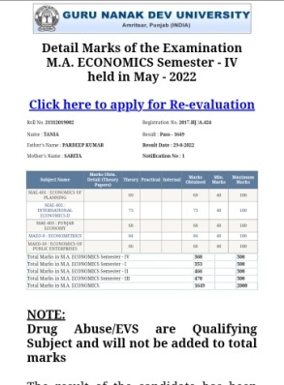
Shivani | 15505 | 17/20 |  | Webinars, PPT Competition | 1622/2000 | 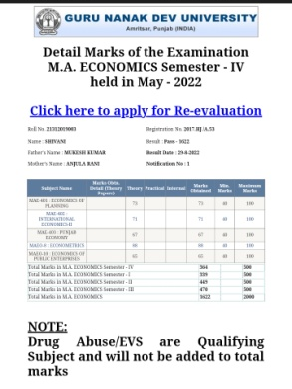
Shriya Dogra | 15504 | 18/20 |  |  | 1492/2000 | 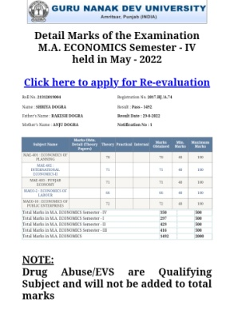

CLASS: B.SC(ECONOMICS) SEM II
Name of the student | College roll no. | Marks obtained in house test(out of 20) | Members of any society/  Organization etc. | Measures taken /  Opportunities given to further enhance skills and confidence of the students | Achievements /outcomes (Marks obtained in university exams out of 100) | Proof of the achievements
Mansi | 12224 | 19/20 | Member of discipline committee,NCC | PPT Competition, webinar | 63/100 | 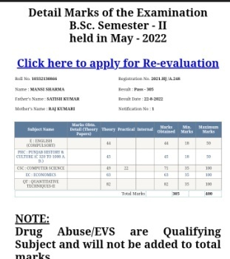
Sadhana | 12209 | 19/20 | Member of discipline committee |  | 68/100 | 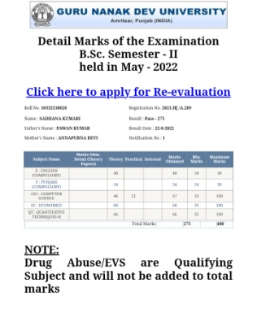
Anshu | 12223 | 18/20 | Member of discipline committee |  | 75/100 | 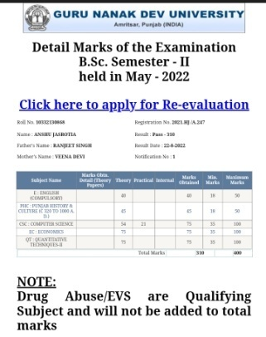

CLASS: B.SC(ECONOMICS) SEM IV
Name of the student | College roll no. | Marks obtained in house test(out of 20) | Members of any society/  Organization etc. | Measures taken /  Opportunities given to further enhance skills and confidence of the students | Achievements /outcomes (Marks obtained in university exams out of 100) | Proof of the achievements
Ridhi | 12002 | 17/20 |  |  | 76/100 | 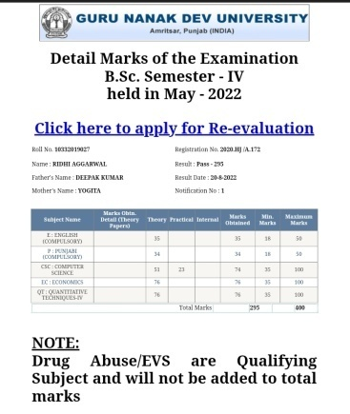
Bhawna | 12005 | 17/20 |  |  | 65/100 | 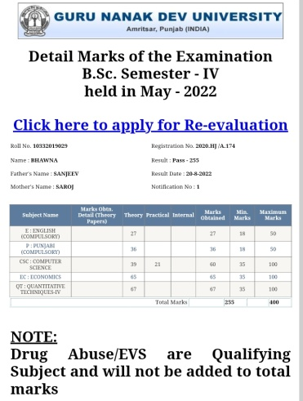
Aman | 12003 | 19/20 |  |  | 70/100 | 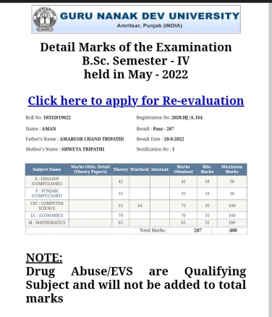

CLASS: B.SC(ECONOMICS) SEM VI
Name of the student | College roll no. | Marks obtained in house test(out of 20) | Members of any society/  Organization etc. | Measures taken /  Opportunities given to further enhance skills and confidence of the students | Achievements /outcomes (Marks obtained in university exams out of 100) | Proof of the achievements
Khushdeep kaur | 6501 | 19/20 |  | E-Declamation competition | 84/100 | 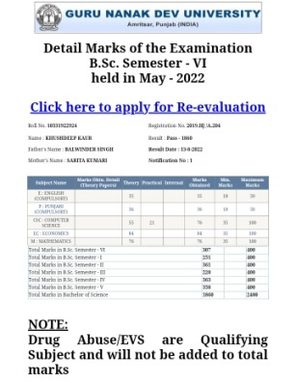
Sujata Sharma | 6522 | 17/20 |  |  | 80/100 | 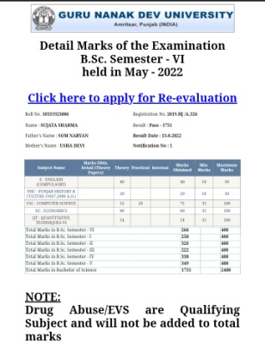
Pranjal Bhagat | 6507 | 19/20 |  |  | 90/100 | 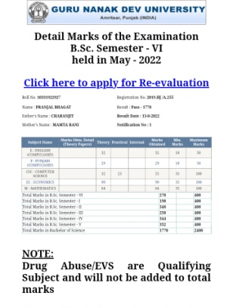

CLASS: M.A(ECONOMICS) IV SEM

Name of the student | College roll no. | Marks obtained in house test(out of 20) | Members of any society/  Organization etc. | Measures taken /  Opportunities given to further enhance skills and confidence of the students | Achievements /outcomes (Marks obtained in university exams out of 2000) | Proof of the achievements
Mamta Chingotra | 3901 | 19/20 | Joint Secretary in Planning Forum | Webinars, PPT Competition and Online quiz competition | 1635/2000 | 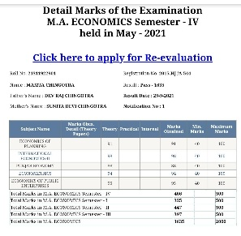

CLASS: M.A(ECONOMICS) II SEM

Name of the student | College roll no. | Marks obtained in house test(out of 20) | Members of any society/  Organization etc. | Measures taken /  Opportunities given to further enhance skills and confidence of the students | Achievements /outcomes (Marks obtained in university exams out of 500) | Proof of the achievements
Tania | 15502 | 19/20 | Assistant Head Girl Student Council | Webinars, online quiz competition, PPT Competition | 466/500 | 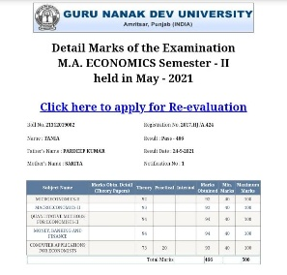
Shivani | 15505 | 18/20 |  | Webinars, PPT Competition | 449/500 | 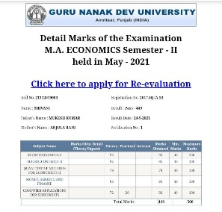
ShriyaDogra | 15504 | 17/20 |  |  | 429/500 | 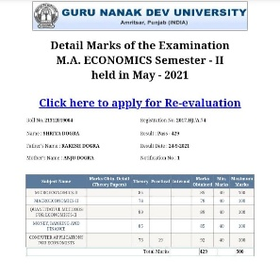

CLASS: B.SC(ECONOMICS) IV SEM
Name of the student | College roll no. | Marks obtained in house test(out of 20) | Members of any society/  Organization etc. | Measures taken /  Opportunities given to further enhance skills and confidence of the students | Achievements /outcomes (Marks obtained in university exams out of 100) | Proof of the achievements
Mehak | 6516 | 19/20 | Assistant Secretary in planning forum | PPT Competition, webinar | 85/100 | 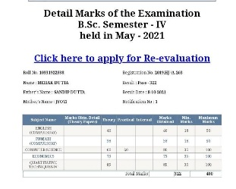
Harman | 6525 | 19/20 |  |  | 85/100 | 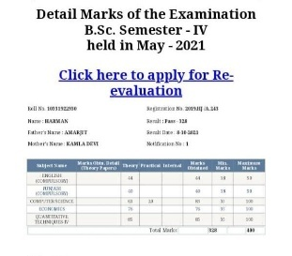
Megha | 6502 | 18/20 |  |  | 77/100 | 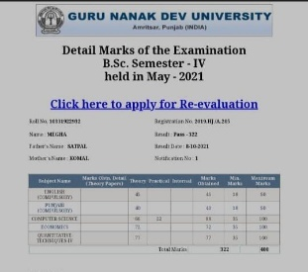
Sujata | 6522 | 17/20 |  |  | 74/100 | 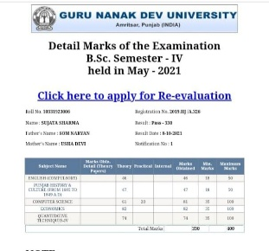
CLASS: B.SC(ECONOMICS) II SEM
Name of the student | College roll no. | Marks obtained in house test(out of 20) | Members of any society/  Organization etc. | Measures taken /  Opportunities given to further enhance skills and confidence of the students | Achievements /outcomes (Marks obtained in university exams out of 100) | Proof of the achievements
Ridhi | 12002 | 18 | Student Council, NSS | E-Declamation competition | 71/100 | 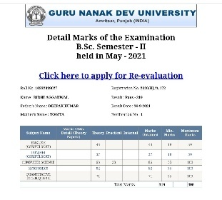
Anupreet | 12010 | 16 |  |  | 67/100 | 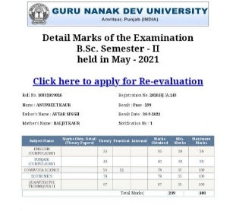
Bhawna | 12005 | 18 |  |  | 72/100 | 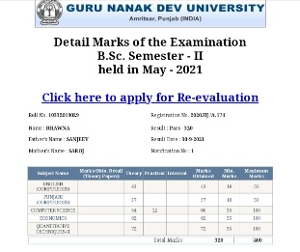
Diksha | 12007 | 19 |  |  | 78/100 | 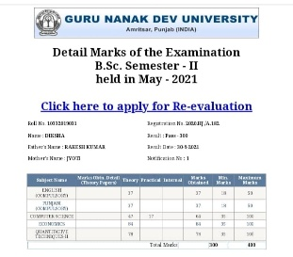

CLASS: B.Sc.(ECONOMICS) VI SEM
Name of the student | College roll no. | Marks obtained in house test(out of 20) | Members of any society/  Organization etc. | Measures taken /  Opportunities given to further enhance skills and confidence of the students | Achievements /outcomes (Marks obtained in university exams out of 100) | Proof of the achievements
Isha Aggarwal | 4501 | 17 |  |  | 88/100 | 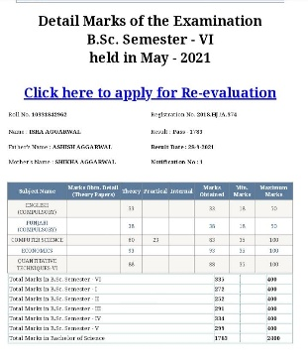
Neha Rani | 4512 | 18 | NSS |  | 97/100 | 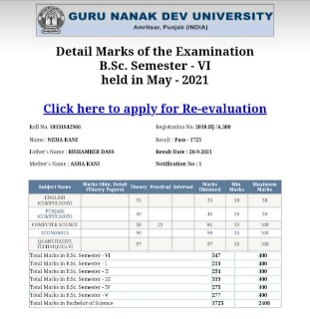
Akshita Aggarwal | 4531 | 19 | NSS |  | 96/100 | 